Ormskirk & District Family History Society - MEMBERSHIP RENEWAL – 2026/27

For online membership renewal, go to the website Membership page or use the following link
https://ormskirk-fhs.co.uk/membership

Membership runs from 1 April 2026 to 31 March 2027 - payments are accepted from 1 January 2026.
NB The Society handles your personal information in a way that complies with the current GDPR.

Membership Number (if known)………………

Title………..First Name(s)………..……………………… Surname………………………………………. Date………….

Address..........................................................................................................................................................................................

..............................................................................................................................................Post Code…………………………

Telephone…………....................................... e-mail address………………………..………………………………………..

I (we) wish to renew my (our) membership for 2026/27 (Delete as required and tick type below)

[ ] UK Membership with Postal Mag. £15.00
[ ] Overseas Membership with Postal Mag. £20.00
[ ] UK or Overseas Membership with E-Mag. £11.00

Method of Payment: Please tick the appropriate box to indicate method of payment and return the completed form to: The Treasurer, ODFHS, 15 Greetby Hill, Ormskirk, Lancashire, L39 2DP (or by email to treasurerodfhs@gmail.com) unless you have applied online.

[ ] CHEQUE - Payable to ‘Ormskirk & District Family History Society’ and enclosed with this form

[ ] BANK TRANSFER Sort Code 77 57 01 Account Number 00007974
Please quote your surname and membership number, if known.

[ ] INTERNATIONAL IBAN GB16TSBS77570100007974 BIC TSBSGB2AXXX
BANK TRANSFER Please quote your surname and membership number, if known.

[ ] DEBIT/CREDIT CARD – Please go to www.parishchest.com/ormskirk-district-fhs-3508.php

[ ] PAYPAL – Go to https://ormskirk-fhs.co.uk/membership and apply online

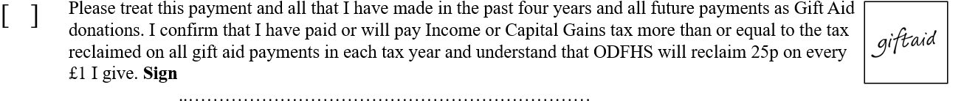
MEMBERS' INTERESTS: PLEASE GIVE DETAILS OF NAMES THAT YOU ARE RESEARCHING
(add years and locations if you wish, and continue on reverse if necessary)

- ……………………………………………… 2) …………………………………………………

3) ………………………………………………… 4) …………………………………………………

5) ………………………………………………… 6) …………………………………………………

Would you like these to be included in the next issue of our Newsletter / Society Magazine? Yes / No
Would you like these to be included in our Members’ Interests Directory? Yes / No

If other members share your interests may we pass on to them:
Your name? Yes / No Your e-mail address? Yes / No
Your postal address? Yes / No Your telephone number? Yes / No

