Ormskirk & District Family History Society - APPLICATION FOR MEMBERSHIP

For online membership applications, go to the website Membership page or use the following link
https://ormskirk-fhs.co.uk/membership

Membership runs from 1 April in the current year to 31 March in the following year. (Applications between 1 January and 31 March run to 31 March in the following year)
NB The Society handles your personal information in a way that complies with the current GDPR

Title………..First Name(s)………..……………………… Surname………………………………………. Date………….

Address..........................................................................................................................................................................................

..............................................................................................................................................Post Code…………………………

Telephone…………....................................... e-mail address………………………..………………………………………..

I (we) wish to apply for membership for 202…./2….. (Tick type below)

[ ] UK Membership with Postal Mag. £15.00 (from 1 January 2024)
[ ] Overseas Membership with Postal Mag. £20.00 “ “
[ ] UK or Overseas Membership with E-Mag. £11.00 “ “

Method of Payment: Please tick the appropriate box to indicate method of payment and return the completed form to: The Treasurer, ODFHS, 15 Greetby Hill, Ormskirk, Lancashire, L39 2DP (or by email to treasurerodfhs@gmail.com) unless you have applied online.

[ ] CHEQUE - Payable to ‘Ormskirk & District Family History Society’ and enclosed with this form

[ ] BANK TRANSFER Sort Code 77 57 01 Account Number 00007974
Please quote your surname and the word “New”.

[ ] INTERNATIONAL IBAN GB16TSBS77570100007974 BIC TSBSGB2AXXX
BANK TRANSFER Please quote your surname and the word “New”.

[ ] DEBIT/CREDIT CARD – Please go to www.parishchest.com/ormskirk-district-fhs-3508.php

[ ] PAYPAL – Please go to https://ormskirk-fhs.co.uk/membership and apply online

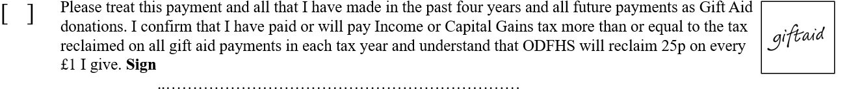

MEMBERS' INTERESTS: PLEASE GIVE DETAILS OF NAMES THAT YOU ARE RESEARCHING
(add years and locations if you wish and continue on reverse if necessary)

- ……………………………………………… 2) …………………………………………………

3) ………………………………………………… 4) …………………………………………………

5) ………………………………………………… 6) …………………………………………………

Would you like these to be included in the next issue of our Newsletter / Society Magazine? Yes / No
Would you like these to be included in our Members’ Interests Directory? Yes / No

If other members share your interests may we pass on to them:
Your name? Yes / No Your e-mail address? Yes / No
Your postal address? Yes / No Your telephone number? Yes / No

